mmmmmmmm

***“Think and Search”***

“***Think and Search***” questions usually require you to think

about how ideas or other information in the passage relate to each other. You will need to look back at the passage, find the information that the question refers to, and then think about how the information or ideas fit together.

“Think and Search” questions sometimes include the words

“The main idea of the passage…” “What caused…” “Compare and contrast…”

***“Right There”***

“***Right There***” questions require you to go back to the passage and find the correct information to answer the question. These are sometimes called literal questions because the correct answer can be found somewhere in the passage. “Right There” questions sometimes include the words “According to the passage…” “How many…” “Who is…” “Where is…” “What is…”

***“On My Own”***

“***On My Own***” questions can be answered using your background knowledge on a topic. This type of question does not usually appear on tests of reading comprehension because it does not require you to refer to the passage. “On My Own” questions sometimes include the words “In your opinion…” “Based on your experience…” “Think about someone/something you know…”

[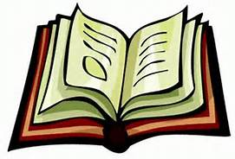](http://www.bing.com/images/search?q=cartoon+of+an+open+book&qs=n&form=QBIR&pq=cartoon+of+an+open+book&sc=0-12&sp=-1&sk=#view=detail&id=2BB2122E79F34C251E3EBE771E77163ECB5914D3&selectedIndex=36) [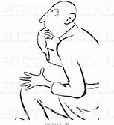](http://www.bing.com/images/search?q=cartoon+of+a+lightbulb+behind+a+man+reading&qs=HS&form=QBIR&pq=cartoon+of+a+lightbulb+behind+a+&sc=1-32&sp=1&sk=#view=detail&id=72281C0CCAB0EE19BDB1D06BDF87555026C65A2E&selectedIndex=5)

[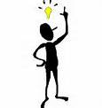](http://www.bing.com/images/search?q=cartoon+of+a+lightbulb+above+a+body+of+a+man&qs=n&form=QBIR&pq=cartoon+of+a+lightbulb+above+a+body+of+a+man&sc=0-8&sp=-1&sk=#view=detail&id=0EBAA700ED0A0E5654304E42C47A8F22BE2EF60C&selectedIndex=0) 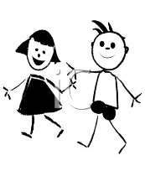

***“Author and You”***

“***Author and You***” questions require you to use ideas and information that is not stated directly in the passage to answer the question. These questions require you to think about what you have read and formulate your own ideas or opinions. “Author and You” questions sometimes include the words “The author implies…” “The passage suggests…” The speaker’s attitude…”